|  |  |
| --- | --- |
| **List of Environmental Conventions** | |
| **Name** | **Year of Establishment** |
| Ramsar Convention | 1971 |
| Stockholm Convention | 2001 |
| CITES | 1973 |
| Convention on Biological Diversity | 1992 |
| Bonn Convention | 1979 |
| Vienna Convention | 1985 |
| Montreal Protocol | 1987 |
| Kyoto Protocol | 1997 |
| United Nations Framework Convention on Climate Change (UNFCCC) | 1992 |
| Rio Summit | 1992 |
| UNCCD | 1994 |
| Basel Convention | 1989 |
| Cartagena Protocol on Biosafety | 2000 |
| UN-REDD | 2008 |
| Nagoya Protocol | 2010 |
| COP24 | 2018 |
| COP21 | 2016 |
| Kigali Amendment | 2016 |
| Minamata Convention | 2013 |
| Rotterdam Convention | 1998 |
| COP25 | 2019 |

Basel Convention on the Control of Transboundary Movements of Hazardous Wastes and their Disposal

Basel Convention on the Control of Transboundary Movements of Hazardous Wastes and their Disposal is a comprehensive treaty that was adopted in 1989 by the Conference of Plenipotentiaries. It aims to protect the human environment from the adverse effects of hazardous waste that is generated, managed and disposed of in the world community. India’s Ministry of Consumer Affairs Food and Public Distribution has announced a blanket ban on all types of single-use plastic products in all its PSUs including Food Corporation in India in September 2019. It is one of the important international [environment conventions](https://byjus.com/free-ias-prep/environment-conventions-protocols/).

What is the aim of Basel Convention?

The Basel Convention aims to protect the environment by bringing measures to control and regulate hazardous and other waste disposals. The negotiations for the convention were started in the late 1980s under the auspices of the [United Nations Environment Programme (UNEP)](https://byjus.com/free-ias-prep/united-nations-environment-programme-unep/).

**Salient Points of Basel Convention:**

1. It came into force in 1992.
2. The Basel Convention **secretariat** is situated in Geneva, Switzerland.
3. It applies **Prior Consent Approval** procedure to regulate the transboundary movement of the hazardous and other wastes.
4. **Non-parties cannot transport hazardous** waste to and from each other unless specially agreed. Basel Convention states such transportation, illegal.
5. The member nations to the convention are required to have **domestic legislation** for both prevention and the punishment of the illegal trafficking of such hazardous wastes.
6. It ensures that the **member nations control the generation**, storage, transportation, treatment, reuse, recycling, recovery and final disposal of hazardous wastes.
7. **Conference of Parties (COP)** is a primary organ of the Basel Convention and is responsible to make decisions about the operations of the convention. It meets biennially.
8. Official site – http://www.basel.int/

What is waste under the Basel Convention?

Basel Convention defines waste as something that needs to be disposed of by the provisions of the national law. Annexes I defines hazardous waste while Annex II defines the other waste.

The table below mentions the **list of wastes that are regulated under the Basel Convention**:

|  |
| --- |
| **Basel Convention – Wastes** |
| * Biomedical and healthcare wastes * Used oils * Used lead acid batteries * Persistent Organic Pollutant wastes (POPs wastes) * Chemicals and pesticides that persist for many years in the environment. * Polychlorinated Biphenyls (PCBs), compounds used in industry as heat exchange fluids, in electric transformers and capacitors, and as additives in paint, carbonless copy paper, sealants and plastics. * Thousands of chemical wastes generated by industries and other consumers |

Apart from the waste, the Basel Convention also handles some topical issues like:

1. Electronic and electrical waste (e-waste) such as mobile phones and computers
2. Ships destined for dismantling
3. Mercury and asbestos wastes
4. Illegal dumping of hazardous wastes

Important Facts about the Basel Convention

1. **Ban Amendment to the Convention** – It was adopted in 1995 which added a new annex VII, and it entered into force on 5th December 2019.
2. **COP 14** – The COP 14 to Basel Convention has been the latest meeting which took place in April-May 2019. It brought new entries into the convention, which will be effective from 1st January 2021 onward.
3. **COP 15** to Basel Convention will take place in July 202 at Geneva.
4. **Basel Protocol on Liability and Compensation for Damage Resulting from Transboundary Movements of Hazardous Wastes and their Disposal –**It has been adopted in 1999 and is yet to come into force. India has yet not signed this protocol.
5. **Radioactive Wastes & Wastes derived from normal operations of the ships**are excluded from the list of hazardous wastes of Basel Convention.
6. **Milestones of Basel Convention:**
   1. Basel Protocol on Liability and Compensation for Damage Resulting from Transboundary Movements of Hazardous Wastes and their Disposal was adopted by COP 5 in 1999.
   2. Strategic Plan for the implementation of the Basel Convention for the period 2002 to 2010 was adopted in 2006.
   3. Bali Declaration on Waste Management for Human Health and Livelihood was adopted by COP 9.

Members of Basel Convention

There are 188 members of the Basel Convention.

**Is India member of Basel Convention**

Yes, India is a member of the Basel Convention. It ratified the convention in June 1992 and brought it into force on 22nd September 1992.

**India’s Domestic Legislation for Waste Management**

1. The Ministry of Environment, Forest & Climate Change (MOEF&CC) introduced **Hazardous and Other Wastes (Management and Transboundary Movement) Rules of 2016**. Recently in 2019, these rules were amended. The amendments were:

* **Prohibition of the import of the solid plastic waste** including in the special economic zone (SEZ) and export-oriented units (EOU).
* **Exemption to Silk Waste Exporters –**They will no longer need permission from the Ministry.
* **Defective electrical and electronic assemblies and components** can be imported back within one year of export without obtaining permission from the ministry.
* **Exemption of Industries** from Hazardous and Other Wastes (Management and Transboundary Movement) Rules of 2016 – Those industries that are already exempted from requiring consent under Water (Prevention and Control of Pollution) Act 1974 and Air (Prevention and Control of Pollution) Act 1981 are now exempted for the same from Hazardous and Other Wastes Rules too.

2. [New Bio-Medical Waste Management Rules 2016](https://byjus.com/free-ias-prep/new-bio-medical-waste-management-rules/) too have been brought by the MOEF&CC.

3. [Electronic Waste – E-waste Management Rules 2016](https://byjus.com/free-ias-prep/electronic-waste/) – MOEF&CC announced these rules replacing E-Waste (Management and Handling) Rules of 2011.

The articles related to plastics can be read by the aspirants to complement Basel Convention notes:

Frequently Asked Questions on Basel Convention 1989

Q 1. When was the Basel Convention adopted?

Ans. The Basel Convention on the Control of Transboundary Movements of Hazardous Wastes and their Disposal was adopted on 22 March 1989.

Q 2. What is the objective of the Basel Convention?

Ans. The key objective of the Basel Convention is to protect the environment by bringing measures to control and regulate hazardous and other waste disposals.

Rotterdam Convention of 1998

Rotterdam Convention is a name for the Convention that was adopted by the Conference of Plenipotentiaries (COP) in 1998 in Rotterdam (Netherlands) that aims to promote shared responsibilities in relation to the international trade of hazardous chemicals. The secretariat of the convention is in Geneva, Switzerland.

Objectives of the Rotterdam Convention

1. The parties of the Rotterdam Convention to ensure shared responsibilities and cooperative efforts while trading certain hazardous chemicals internationally.
2. To promote shared responsibility in the international trade of such hazardous chemicals which can harm humans and its environment.
3. To exchange information about the characteristics of the chemicals that the parties to the convention trade so as to contribute to the environmentally sound use of such hazardous chemicals.

The Convention creates legally binding obligations for the implementation of the **Prior Informed Consent (PIC) procedure**. It built on the voluntary PIC procedure, initiated by [United Nations Environment Programme](https://byjus.com/free-ias-prep/united-nations-environment-programme-unep/) (UNEP) and [Food and Agriculture Organisation](https://byjus.com/free-ias-prep/food-and-agriculture-organisation-fao/) (FAO) in 1989 and ceased on 24 February 2006.

**What is Prior Informed Consent (PIC) Procedure in the Rotterdam Convention?**

It is one of the main provisions of the Rotterdam Convention of 1998 that states that parties that are importing the chemicals as listed in Annex III of the Convention have to formally obtain and disseminate the decision of receiving future shipments of such chemicals. The importing pirates have to ensure that decisions related to their import are well in compliance by the exporting parties.

There are 52 chemicals listed in Annex III of the Rotterdam Convention for the trade of which parties have to follow the mechanism of Prior Informed Consent Procedure.

Provisions of Rotterdam Convention

The following are the provisions covered under the Rotterdam Convention:

1. The convention covers those pesticides and industrial chemicals that are banned or severely restricted.
2. Any concern related to pesticides and industrial chemicals promotes their inclusion on Annex III of the convention.
3. Annex III other than comprising chemicals that need PIC, also may contain those chemicals and pesticides that present a risk under conditions of use in developing countries or countries with economies in transition.
4. A decision guidance document (DGC) contains all the information regarding the chemicals mentioned under Annex III.
5. With respect to the chemicals under Annex III, the member parties have the following choices:
   * To allow its import
   * To disallow its import
   * To allow its import with some conditions
6. A country that imports chemicals has to formulate decisions that are trade-neutral.

Two Important Mechanisms of the Rotterdam Convention

There are two important mechanisms under the Rotterdam Convention:

1. **PIC Procedure** (Explained above)
2. **Information Exchange** – It is a mechanism under which parties have to inform the Secretariat when they take a domestic regulatory action to ban or severely restrict a chemical. Any party that is exporting a chemical which is banned in its territory has to comply with the guideline to inform all the importing parties before its first shipment.

|  |
| --- |
| Two industrial chemicals that are being discussed recently to be included in the PIC procedure (Annex III) are:   1. Decabromodiphenyl ether (decaBDE) 2. Perfluorooctanoic acid (PFOA)   Two new chemicals that were added in the list of mandatory PIC procedure in COP9 of Rotterdam Convention:   1. Phorate 2. HBCD |

Rotterdam Convention – Conference of Parties (RC – COP)

* **RC COP 9** – It was the ninth meeting of the conference of parties to the Rotterdam Convention that met in April-May 2019 in Geneva, Switzerland.
* **RC COP 10** – It will be the 10th meeting of COP that is scheduled to meet in July 2021 in Geneva. The RC COP 10 will take place along with the [Stockholm Convention](https://byjus.com/free-ias-prep/stockholm-convention-on-persistent-organic-pollutants/) (COP 10) and Basel Convention (COP 15). The three conventions together are termed as BRS Convention as they share the same secretariat but enjoy the legal independence of their work. **The theme of the Rotterdam convention COP 10 is “Global Agreements for a Healthy Planet: Sound management of chemicals and waste”.**

Members of Rotterdam Convention

There are 163 parties of the Rotterdam Convention and 72 signatories.

**Is India a member of the Rotterdam Convention?**

Yes, India is a member of the Rotterdam Convention:

* India’s acceded to Rotterdam Convention on 24th May 2005
* Rotterdam Convention came into force in India – 22nd August 2005

**What is Chrysotile Asbestos and what is India’s stand?**

|  |
| --- |
| Asbestos is a group of six naturally occurring minerals composed of soft, flexible fibres that are heat-resistant and is highly toxic. It is termed as carcinogenic as it causes mesothelioma. |

Chrysotile Asbestos is a well-debated mineral that is speculated to be added in Annex III of the Rotterdam convention. However, the parties have not unanimously agreed to the addition of Asbestos until now.

**India’s stand:**

1. India has opposed the listing of Asbestos under Rotterdam Convention’s PIC procedure. India though has banned asbestos mining in India.
2. India’s Fiber Cement Product Manufacturer’s Association in the COP 9 to the Rotterdam Convention opposed the listing of Asbestos in Annex III, saying there were no Indian studies showing negative health impacts from chrysotile exposures.
3. The use of Asbestos is prevalent in India, though the Ministry of Environment has stated, “Alternatives to asbestos may be used to the extent possible and use of asbestos may be phased out.”
4. The Ban Asbestos Network of India (BANI) has been working towards an asbestos-free India to safeguard the health of the present and future generations.

Rotterdam Convention is one of the important environmental conventions.

Frequently Asked Questions related to the Rotterdam Convention

Is the Rotterdam Convention legally binding?

The Convention creates legally binding obligations for the implementation of the Prior Informed Consent (PIC) procedure.

Is India part of the Rotterdam Convention?

India acceded to the Convention on 24.05. 2006.

How many countries are there in the Rotterdam Convention?

As of October 2018, the convention has 161 parties, which includes 158 UN member states, the Cook Islands, the State of Palestine, and the European Union. Non-member states include the United States.

Stockholm Convention on Persistent Organic Pollutants (POPs)

Conference of Parties (COP) 10 to Stockholm Convention on Persistent Organic Pollutants (Adopted in 2001 by Conference of Plenipotentiaries) will take place in July 2021 in Geneva, Switzerland. In July 2020, new restrictions on Perfluorooctanoic acids (PFOAs) came into effect, bringing into the news, Stockholm Convention

What are Persistent Organic Pollutants (POPs)?

Persistent Organic Pollutants are carbon-based organic chemical substances that display the following properties once they are released into the environment:

1. **Lifespan –**They remain in the environment for long periods of time counted in years.
2. **Distribution –**The natural carriers like soil, water and air distribute it throughout the environment
3. **Food Chain –**They become a part of the food chain by getting accumulated in the fatty tissue of living organisms including humans
4. **Toxicity –**They are termed as toxic for both humans and wildlife.
5. **Bioaccumulation –**The POPs get accumulated in the fatty tissues and its concentration gets magnified. The species including at the higher level of the food chain absorb greater concentrations of POPs and carry it along.
6. **Effect –**The exposure to POPs can cause:
   1. Cancer
   2. Allergies
   3. Hypersensitivity
   4. Damage to the central and peripheral nervous systems
   5. Reproductive disorders, and
   6. Disruption of the immune system
   7. Endocrine disruptors

What are the 12 Persistent Organic Pollutants?

The Stockholm Convention initially recognized 12 POPs causing adverse effects on the environment. These are categorized into three categories:

|  |  |  |
| --- | --- | --- |
| **Pesticides** | **Industrial Chemicals** | **By-Products** |

The 12 POPS under these three categories are given in the table below:

|  |  |
| --- | --- |
| **Stockholm Convention – 12 POPs** | |
| **Category** | **Persistent Organic Pollutant** |
| Pesticide | 1. Aldrin 2. Chlordane 3. DDT 4. Dieldrin 5. Endrin 6. Heptachlor 7. Hexachlorobenzene 8. Mirex 9. Toxaphene |
| Industrial Chemicals | 1. Hexachlorobenzene 2. Polychlorinated biphenyls (PCBs) |
| By-Products | 1. Polychlorinated dibenzo-p-dioxins and Polychlorinated dibenzofurans (PCDD/PCDF) |

In 2017, 16 additional POPs were added under the Stockholm Convention. Those 16 new POPs are mentioned in the table below:

|  |  |
| --- | --- |
| **16 New POPs added under Stockholm Convention** | |
| Alpha hexachlorocyclohexane | Pentachlorobenzene |
| Beta hexachlorocyclohexane | Pentachlorophenol and its salts and esters |
| Chlordecone | Perfluorooctane sulfonic acid (PFOS), its salts and perfluorooctane sulfonyl fluoride (PFOSF) |
| Hexabromobiphenyl | Polychlorinated naphthalenes |
| Hexabromocyclododecane | Technical endosulfan and its related isomers |
| Hexabromodiphenyl ether  and heptabromodiphenyl ether  (commercial octabromodiphenyl ether) | Tetrabromodiphenyl ether  and pentabromodiphenyl ether (commercial  pentabromodiphenyl ether) |
| Hexachlorobutadiene | Decabromodiphenyl ether  (Commercial mixture, cDecaBDE) |
| Lindane | Short-chain chlorinated paraffins (SCCPs) |

What is the Stockholm Convention?

**History of Stockholm Convention**

Stockholm Convention is a global treaty that was adopted by the Conference of Plenipotentiaries in 2001 and came into force on 17th May 2004. It was introduced to protect human health from harmful POPs suspended in the air for a long period of time. The convention aims to reduce or eliminate the use of POPs through the active measures of the member states.

**Salient Points on Stockholm Convention:**

* The [Global Environmental Facility (GEF)](https://byjus.com/free-ias-prep/global-environment-facility-g-e-f/) is the designated interim financial mechanism for the Stockholm Convention.
* The [United Nations Industrial Development Organization (UNIDO)](https://byjus.com/free-ias-prep/united-nations-industrial-development-organization-unido/) takes the responsibility for developing nations and transitioning economies to help them implement Stockholm Convention measures.

**Objectives & Aims of the Stockholm Convention**

1. To implement control measures for the POPs
2. To develop and implement action plans for unintentionally produced chemicals
3. To develop inventories of the chemicals’ stockpiles
4. To review and update the National Implementation Plan
5. To include the new chemicals in the reporting
6. To include the new chemicals in the programme for the effectiveness evaluation

There are three annexes under Stockholm Convention that define which POPs are eliminated, restricted and which unintentionally produced POPs will be reduced:

1. **Annex A**– Chemicals listed under this annexure are to be eliminated by the member states (Some exceptions are given.)
2. **Annex B** – Chemicals listed under this annexure are to be restricted for their use. (Some exceptions are given.)
3. **Annex C** – Unintentionally produced chemicals are to be reduced with measures for ultimate elimination under this annexure.

Members of Stockholm Convention

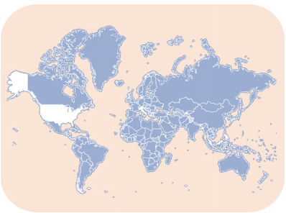

As of May 2017, there are 181 parties to the Stockholm Convention who have ratified it.

**Is India a member of Stockholm convention?**

Yes, India is a party to the Stockholm Convention. In May 2002, India signed the global treaty whereas it brought it in force in January 2006.

**POPs & India**

* According to The Energy and Resources Institute (TERI) January 2018 report on POPs in Indian Environment, the level of POPs in Indian environment is high because of poor management of e-waste and municipal and industrial wastes.
* India has been exempted from the ban of DDT as a result of the Stockholm Convention (SC) and is allowed to produce and use DDT—but only for the control of vector-borne diseases.

**India’s efforts towards meeting the aims of the Stockholm Convention**

* Promotion of **non-POP alternatives**
* **Insecticide Act, 1968** – Banning of use, manufacture and import of most of the listed POPs under Stockholm Convention into India Insecticide Act, 1968
* India submitted its **National Implementation Plan (NIP) on Persistent Organic Pollutants** in 2011 (It is yet to include 16 additionally added POPs.)

**Conclusion**

Stockholm Convention is considered as a step towards a detoxified future.

Rio Earth Summit 1992

The United Nations Conference on Environment and Development (UNCED), also known as the Rio de Janeiro Earth Summit, Rio Summit, Rio Conference, and Earth Summit (Portuguese: ECO92), was a major [United Nations](https://byjus.com/free-ias-prep/united-nations-organization/) conference held in Rio de Janeiro (Brazil) from 3 to 14 June 1992. 172 governments participated, with 116 sending their heads of state or government.

Rio Summit

Some 2,400 representatives of non-governmental organizations (NGOs) attended, with 17,000 people at the parallel NGO “Global Forum” (also called Forum Global), who had Consultative Status. A significant accomplishment of the summit was an agreement on the Climate Change Convention which in turn led to the [Kyoto Protocol](https://byjus.com/free-ias-prep/kyoto-protocol/)and the Paris Agreement. Another agreement was “not to carry out any activities on the lands of indigenous peoples that would cause environmental degradation or that would be culturally inappropriate”.

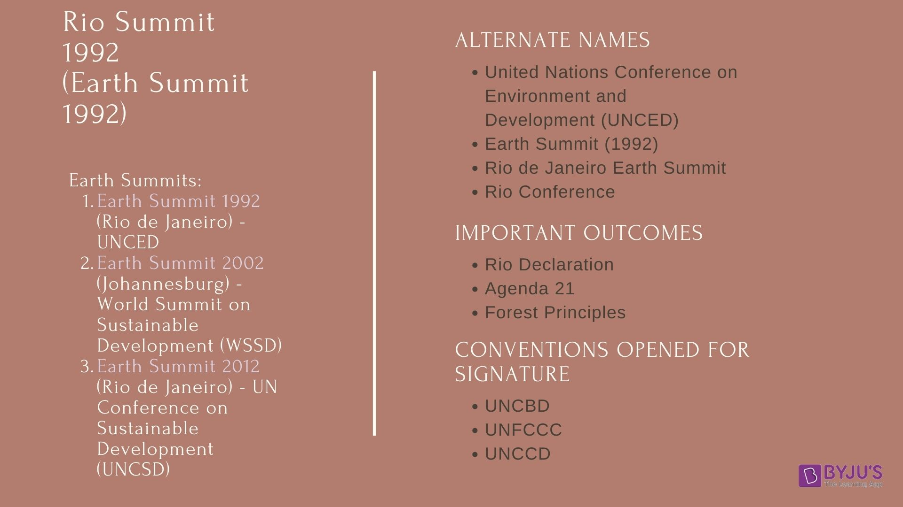

Rio Summit 1992 – Important Outcomes

The Rio Summit 1992 is also called the Earth Summit. This summit led to the development of the following documents:

1. Rio Declaration on Environment and Development
2. Agenda 21
3. Forest Principles

The first document called the **Rio Declaration,** in short, contained 27 principles that were supposed to guide countries in future sustainable development. **Agenda 21** is an action plan concerning sustainable development, but it is non-binding. The **Forest Principles** is formally called ‘Non-Legally Binding Authoritative Statement of Principles for a Global Consensus on the Management, Conservation and Sustainable Development of All Types of Forests’. It makes many recommendations for conservation and sustainable development forestry and is non-binding.

United Nations Convention on Biological Diversity (UNCBD)

The United Nations Convention on Biological Diversity (UNCBD) is a United Nations treaty that is responsible for the conservation of Biological Diversity around the world. The UNCBD is one of the important parts of [international environment conventions and protocols](https://byjus.com/free-ias-prep/environment-conventions-protocols/) particularly covering the environment, ecology and biodiversity, and also the international relations.

What is the United Nations Convention on Biological Diversity (UNCBD)?

The United Nations Convention on Biological Diversity, informally known as the Biodiversity Convention, is a multilateral treaty opened for signature at the Earth Summit in Rio De Janeiro in 1992. It is a key document regarding sustainable development. It comes under the [United Nations Environment Programme (UNEP)](https://byjus.com/free-ias-prep/united-nations-environment-programme-unep/).

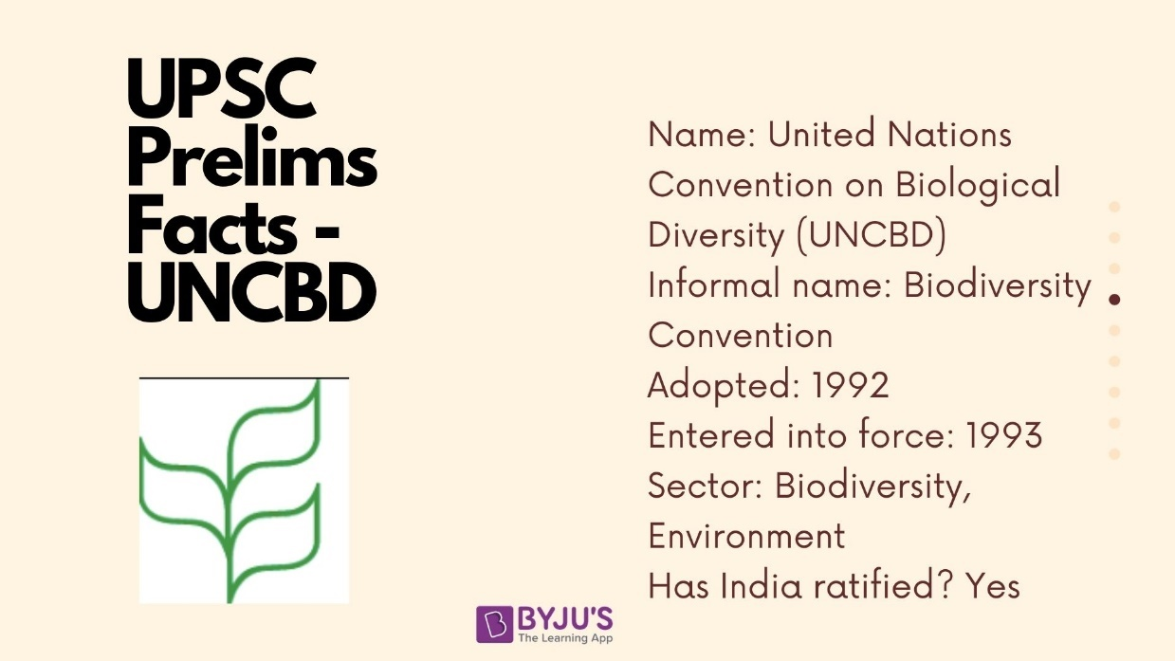

* 196 countries are a party to the CBD.
* India is also a party to the Convention. India ratified it in 1994.
  + The Biological Diversity Act, 2002 was enacted for giving effect to the provisions of the Convention.
  + To implement the provisions of the Act, the government established the National Biodiversity Authority (NBA) in 2003. The NBA is a statutory body.
* The convention is legally binding on its signatories.
* The Conference of Parties (COP) is the governing body of the convention. It consists of the governments that have ratified the treaty.
* Its Secretariat is in Montreal, Canada.
* Only two member states of the United Nations are not Parties to the CBD, namely: the USA and the Vatican.
* In the 1992 Earth Summit, two landmark binding agreements were signed, one of them being the UNCBD. The other one was the Convention on Climate Change.
* More than 150 countries signed the document at the Summit, and since then, over 175 nations have ratified the agreement.

Goals of the Convention on Biological Diversity

The goals of the Convention are listed below:

1. Conservation of Biological Diversity
2. Sustainable use of the components of the Biodiversity
3. Fair and equitable sharing of benefits arising from the genetic resources

The idea of CBD is to develop national strategies for the conservation and sustainable use of biological diversity. In order to implement that, the convention does the following:

|  |  |
| --- | --- |
| 1 | Asserting intrinsic value of biodiversity |
| 2 | Affirming conservation of biodiversity as a common concern of population |
| 3 | Taking responsibility to conserve biodiversity in the State and that the state uses this biodiversity sustainably |
| 4 | Affirming the State to put the biological resources as the Sovereign Rights of the State. |
| 5 | Taking a precautionary approach towards conservation of biodiversity |
| 6 | Highlighting the vital role of local communities and women |
| 7 | Supporting access to technologies for developing countries and searching for provisions for new and additional financial resources to address the biodiversity loss in the region |

All genetic resources, species and ecosystems are covered in the agreement. Traditional conservation efforts are linked to the economic goal of using biological resources sustainably. A set of principles are laid out for equitable and fair sharing of the benefits that arise out of the use of genetic resources, specifically those destined for commercial use.

It also covers the rapidly expanding field of biotechnology through its Cartagena Protocol on Biosafety, addressing technology development and transfer, benefit-sharing and biosafety issues.

UNFCCC - United Nations Framework Convention on Climate Change

UNFCCC is an acronym for the United Nations Framework Convention on Climate Change. It came into force on 21st March 1994. It has been ratified by 197 countries and is called to have a near-universal membership. The countries that have ratified the convention are called the UNFCCC conference of parties (COP). The latest, COP26, was scheduled to be held in Glasgow, Scotland in November 2020, but was postponed due to the COVID-19 pandemic. The rescheduled conference would most likely be held in November 2021 hosted in Glasgow by the UK in partnership with Italy.

United Nations Framework Convention on Climate Change (UNFCCC)

UNFCCC is the primary multilateral treaty governing actions to combat climate change through adaptation and mitigation efforts directed at control of emission of Green House Gases (GHGs) that cause global warming. Even though climate change is a global concern some of the countries are majorly responsible for greenhouse gas emissions into the atmosphere. Many island nations are facing the major brunt of this [Climate Change](https://byjus.com/free-ias-prep/ncert-notes-geography-climate-change/) in the form of sea-level rise, cyclones, erratic weather conditions, etc. UNFCCC is a major step in the direction to control the downward spiral of climate change.

It is called the Rio Convention along with its sister conventions:

1. [UN Convention on Biological Diversity](https://byjus.com/free-ias-prep/uncbd-united-nations-convention-on-biological-diversity/) and
2. [UN Convention to Combat Desertification.](https://byjus.com/free-ias-prep/unccd-united-nations-convention-to-combat-desertification/)

* The first global conference on climate change was held in 1972 in Stockholm, Sweden.
* This conference ushered in numerous global negotiations and international agreements on the environment.
* All of these culminated in the establishment of the United Nations Framework Convention on Climate Change (UNFCCC) in Rio de Janeiro in Brazil, in 1992.
* The treaty sets limits on GHG emissions on countries, but these are not binding and there are no enforcement mechanisms either.
  + However, there are provisions for updates or protocols that can be used to set legally binding emission limits on countries.
* The parties to the convention meet annually in the Conference of the Parties or COP to review the progress under the convention.

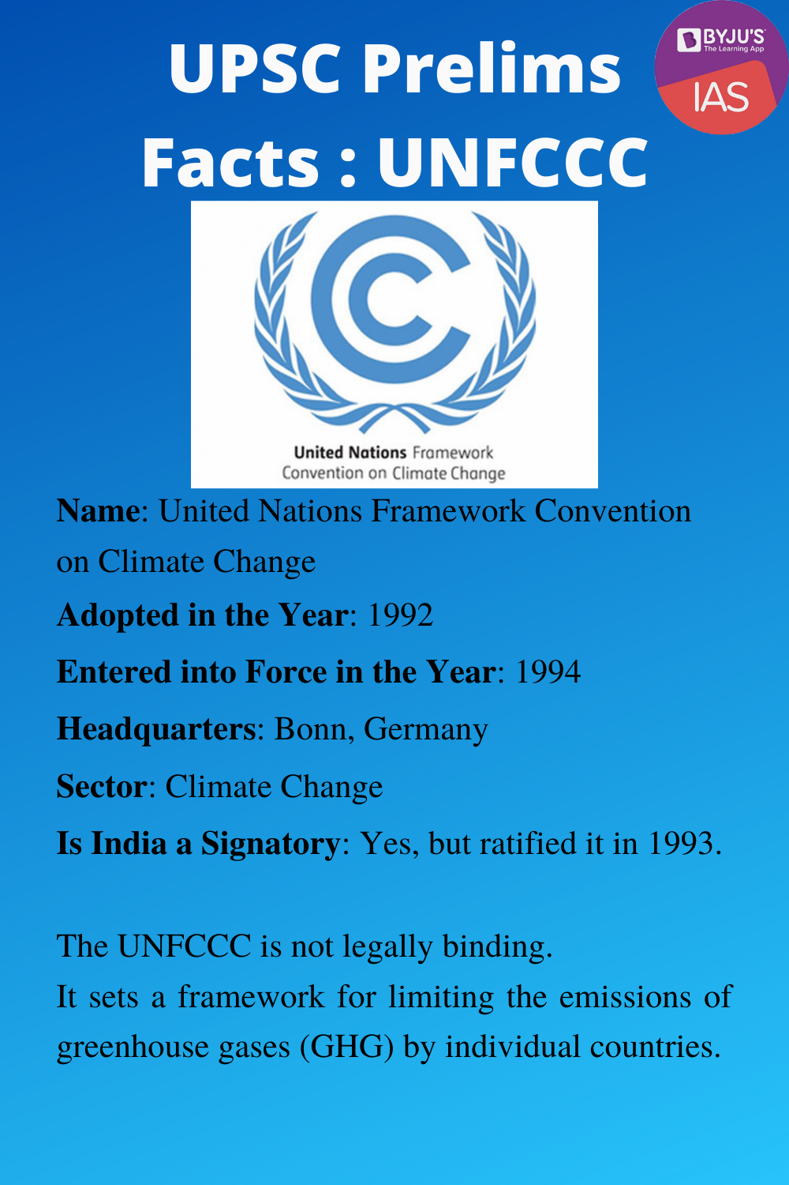

Other Prelims Key Facts about UNFCCC

**How Many Signatory Parties are there of the Agreement?**

* As of 2020, the UNFCCC has 197 signatory parties.

**When does its supreme decision-making body meets?**

* Its supreme decision-making body, the Conference of the Parties (COP), meets annually to assess progress in dealing with climate change.

Categories of Parties (Countries) associated with UNFCCC

The categories of countries that are signatories to UNFCCC are given in the table below:

|  |  |
| --- | --- |
| **Category of Parties** | **Meaning** |
| **Annex I** | 43 parties (countries) come under this category. The countries that come under this category are developed countries. |
| **Annex II** | 24 countries of Annex I also come under Annex II countries. The countries in this category are expected to provide technical and financial assistance to countries coming under the category of developing countries. |
| **Annex B** | The countries in this category are Annex I countries, who have first or second-round Kyoto greenhouse gas emissions target. |
| **Least-developed countries (LDCs)** | 47 Parties (countries) come under the category of LDCs. These countries are given special status under the treaty taking into consideration their limitations adapting to the effects of climate change. |
| **Non Annex I** | Parties (countries) that are not listed in Annex I that come under the category of low-income developing countries. |

The **Kyoto Protocol** was adopted at the third session of the UNFCCC. Read more about the [Kyoto Protocol](https://byjus.com/free-ias-prep/kyoto-protocol/) in the linked article. This protocol is based on the principle of common but differentiated responsibilities, keeping in mind the socio-economic development of the concerned countries and the polluter pays principle.

Another important agreement within the UNFCCC is the [Paris Agreement](https://byjus.com/free-ias-prep/paris-agreement/) (COP 21) which aims to reduce and mitigate GHG emissions.

United Nations Framework Convention on Climate Change (UNFCCC) and India

* India ratified the UNFCCC in 1993.
* The nodal agency for the UNFCCC in India is the Ministry of Environment, Forests and Climate Change (MoEFCC).
* Since India is a developing country, it is not required to adhere to GHG mitigation commitments because of its relatively smaller emissions and also because of lesser technical and financial capacities.
* India has been a big champion of the principles of Equity and Common But Differentiated Responsibilities and Respective Capability (CBDR-RC) at the Convention.
* This is primarily based on the belief that developed countries have largely been responsible for the huge emission levels, owing to their being industrialized decades before the other countries.
  + A scientific study carried on greenhouse gas emissions from the time period 1850 to 2012 estimated that the US, China and the European Union would contribute to 50 per cent of temperature increase by 2100.
  + The total emissions’ share in the given time period of the US, [European Union](https://byjus.com/free-ias-prep/european-union-eu/), and China is 20%, 17%, 12% respectively.
  + On the other hand, India is responsible for only 5%.
* Another reason is that developing countries and LDCs would have to accord eradicating poverty and other developmental activities more priority as compared to environmental concerns. So, they should be allowed leeway in assessing capabilities in addressing climate change.
* India has played an active role in taking steps to mitigate climate change, as the country is exposed to risks associated with climate change like erratic monsoons and natural calamities like floods, droughts, landslides, etc.
* National Environment Policy, 2006 promotes sustainable development along with respect for ecological constraints and the imperatives of social justice.
* The Government of India launched the [National Action Plan on Climate Change](https://byjus.com/free-ias-prep/national-action-plan-on-climate-change/) in 2008. Read more about it in the linked article.
* At COP 21 (Paris Agreement), India had made various commitments to be achieved by 2030.
  + One commitment was to create an additional carbon sink of 2.5 to 3 billion tonnes of CO2 equivalent through additional forest and tree cover by 2030.
  + For more on the commitments made by India, check the article on Paris Agreement.
* India was instrumental in the formation of the Coalition for Disaster Resilient Infrastructure. Read more about it in [PIB dated Nov 14, 2019](https://byjus.com/free-ias-prep/upsc-pib-summary-analysis-nov14-2019/#Coalition%20for%20Disaster%20Resilient%20Infrastructure).
* In the UN Climate talks that were held in Poland, India reiterated that the CBDR principle must be adhered to even as there were growing concerns that developed countries were trying to dilute it.

UNFCCC COP

There are a total of 25 COPs to UNFCCC that have met since 1994.  The list of UNFCCC Conference of Parties is given below:

|  |  |
| --- | --- |
| **UNFCCC Conference of the Parties** | |
| UNFCCC COP1 | 1985, Berlin |
| UNFCCC COP2 | 1996, Geneva |
| UNFCCC COP3 | 1997, Kyoto |
| UNFCCC COP4 | 1998, Buenos Aires |
| UNFCCC COP5 | 1999, Bonn |
| UNFCCC COP6 | 2001, The Hague |
| UNFCCC COP7 | 2001, Marrakesh |
| UNFCCC COP8 | 2002, New Delhi |
| UNFCCC COP9 | 2003, Milan |
| UNFCCC COP10 | 2004, Buenos Aires |
| UNFCCC COP11 | 2005, Montreal |
| UNFCCC COP12 | 2006, Nairobi |
| UNFCCC COP13 | 2007, Bali |
| UNFCCC COP14 | 2008, Poznan |
| UNFCCC COP15 | 2009, Copenhagen |
| UNFCCC COP16 | 2010, Cancun |
| UNFCCC COP17 | 2011, Durban |
| UNFCCC COP18 | 2012, Doha |
| UNFCCC COP19 | 2013, Warsaw |
| UNFCCC COP20 | 2014, Lima |
| UNFCCC COP21 | 2015, Paris |
| UNFCCC COP22 | 2016, Marrakesh |
| UNFCCC COP23 | 2017, Bonn |
| [UNFCCC COP24](https://byjus.com/free-ias-prep/cop24-unfccc/) | 2018, Katowice |
| [UNFCCC COP25](https://byjus.com/free-ias-prep/cop25-unfccc/) | 2019, Madrid |

Frequently Asked Questions Related to the UNFCC

How effective the UNFCC has been?

The UNFCCC process has not been effective enough in catalysing mitigation action compatible with a below-2°C trajectory because its historical focus on emission targets has been too narrow

What are the drawbacks of the UNFCC?

The UNFCCC was born in 1992 with three fatal flaws: a static annex system, interlinked decision-making and no formal rules of procedure.

UNCCD - United Nation Convention to Combat Desertification

UNCCD stands for United Nations Convention to Combat Desertification. Established in 1994, UNCCC is a sole legally binding [environment convention](https://byjus.com/free-ias-prep/environment-conventions-protocols/) that links development and environment to sustainable land management.

The UN Convention to Combat Desertification aims to combat desertification and the ill-effects of drought. Learn about this convention, UNCCD COP14, UNCCD 2018-30 Strategic Framework and basic facts.

UNCCD – Basic Facts

The UNCCD is a [United Nations](https://byjus.com/free-ias-prep/united-nations-organization/) convention aimed at addressing desertification and droughts.

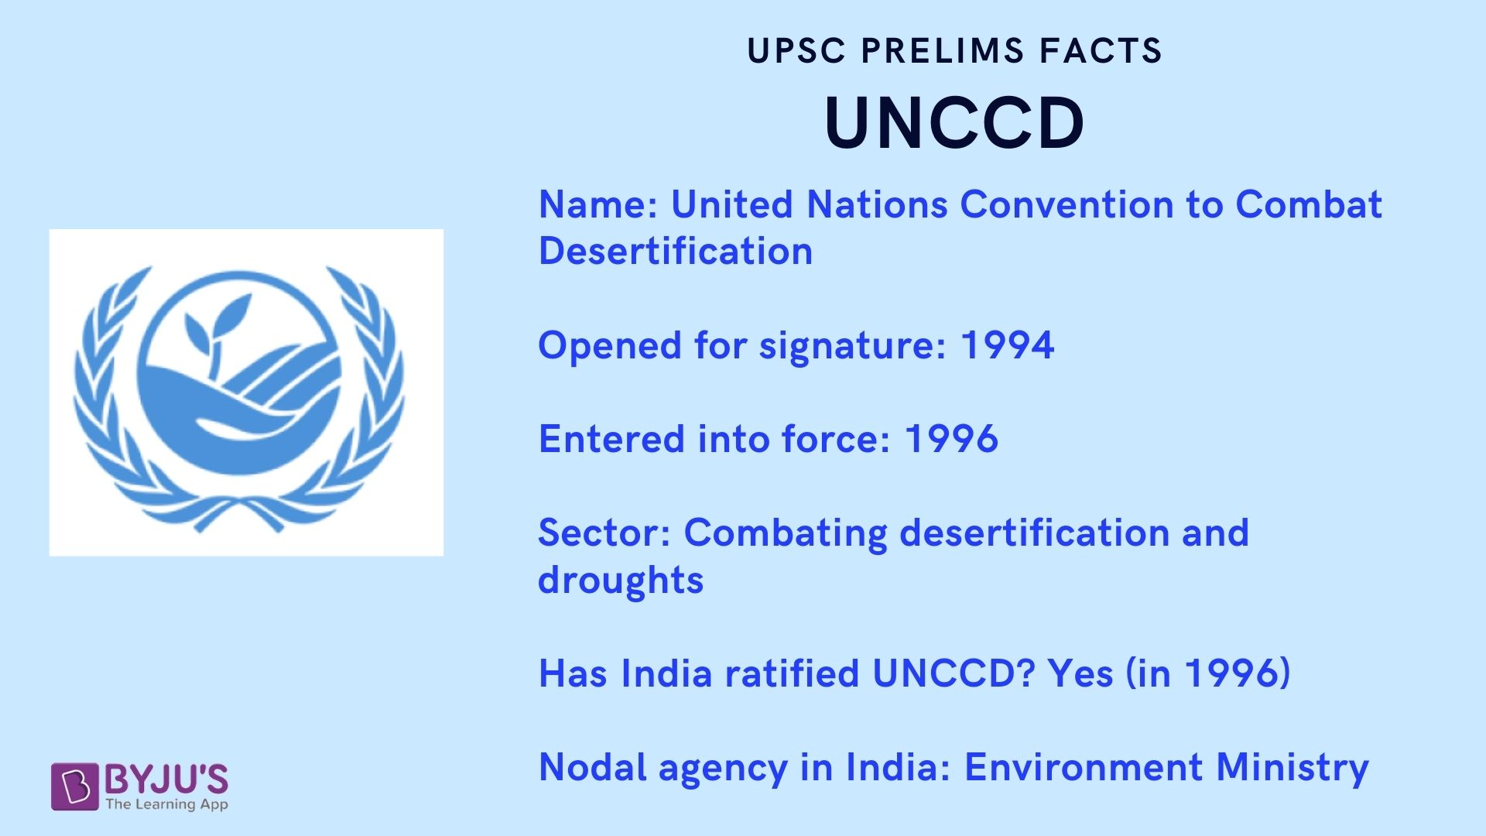

* It is a legally binding convention linking development and environment to sustainable land management.
* The UNCCD addresses particularly the arid, semi-arid & dry sub-humid areas, called **drylands**, where some of the most vulnerable ecosystems and peoples are found.
* The convention was drafted and opened for signing in 1994. It became effective in 1996 after receiving 50 ratifications.
* The convention obliges national governments to take measures to tackle the issue of desertification.
* The convention’s 2018 – 2030 Strategic Framework is a comprehensive international commitment to attain Land Degradation Neutrality (LDN) aiming at:
  + The restoration of productivity of degraded land.
  + Enhancing the livelihoods of people dependent on them.
  + Mitigating the impact of droughts on vulnerable populations.
* The convention focuses on having a bottom-up approach to achieve its goals, by involving the local communities.
* The UNCCD is one of the three **Rio Conventions**, the other two being:
  + [Convention on Biological Diversity (UNCBD)](https://byjus.com/free-ias-prep/uncbd-united-nations-convention-on-biological-diversity/)
  + [United Nations Framework Convention on Climate Change (UNFCCC)](https://byjus.com/free-ias-prep/the-united-nations-framework-convention-on-climate-change-unfccc/)
* The three Rio Conventions work in close collaboration with each other.
* To spread the word about the UNCCD, 2006 was declared as “International Year of Deserts and Desertification”.

UNCCD and India

India ratified the Convention to Combat Desertification in December 1996.

* The nodal ministry for the convention in India is the Ministry of Environment, Forest and Climate Change.
* India faces a huge desertification problem. A 2016 ISRO report stated that 29% of the land in India was degraded.
* The 14th Conference of Parties (COP) to the UNCCD was held in India in 2019.
  + The conference which was held in Greater Noida had the theme, “Restore Land, Sustain Future”.
  + India is the COP president for 2019 – 2021.
  + India is also a part of the [Bonn Challenge](https://byjus.com/free-ias-prep/bonn-challenge/), which is an international effort to bring 150 million hectares of the world’s degraded and deforested land into restoration by 2020, and 350 million hectares by 2030.

UNCCD – COP 14

The UNCCD COP 14 (14th edition of Conference of Parties) ended on 13 September 2019. This was the first time that India hosted an edition of the UNCCD COP. India is among the select few countries to have hosted the COP of all three Rio conventions on climate change, biodiversity and land.

**Important Takeaway from UNCCD COP 14-**

* The theme of the Conference was ‘Restore land, Sustain future’.
* The Conference adopted the Delhi Declaration and expressed a range of issues which includes gender and health, ecosystem restoration, taking action on climate change, private sector engagement, Peace Forest Initiative and recovery of 26 million hectares of degraded land in India.

|  |
| --- |
| **What is the Peace forest Initiative?**  An initiative of South Korea to use ecological restoration as a peace-building process.  The Peace Forest initiative aims at addressing the issue of land degradation in conflict-torn border areas and would go a long way in alleviating tensions and building trust between communities living there and between enemy countries in particular. |

* The country parties have agreed to make the [Sustainable Development Goal](https://byjus.com/free-ias-prep/sustainable-development-goals/) target of achieving land degradation neutrality by 2030, a national target for action.
* A one-stop shop for all actions on drought called Drought Toolbox is launched. It is a sort of knowledge bank which contains tools that strengthen the ability of countries to anticipate and prepare for drought effectively and mitigate their impacts as well as tools that enable communities to anticipate and find the land management tools that help them to build resilience to [drought](https://byjus.com/free-ias-prep/droughts/).
* To address migration driven by land degradation an initiative 3S i.e. Sustainability, Stability and Security is launched by 14 African countries. The main aim is at restoring land and creating green jobs for migrants and vulnerable groups.
* The global Youth Caucus on Desertification and Land convened its first official gathering in conjunction with the UNCCD COP14 to bring together youth advocates from different parts of the world, to build their capacity, share knowledge, build networks, and to engage them meaningfully in the UNCCD processes.
* International coalition for action on Sand and Dust storms (SDS): The coalition will develop an SDS source base map with the goal of improving monitoring and response to these storms. SDS affects approximately 77% of UNCCD country Parties or approximately 151 countries.

**UNCCD COP 14 High-Level Segment Meeting**

Prime Minister Narendra Modi inaugurated the High-Level Segment (HLS) of UNCCD COP14.

1. India to promote [south-south cooperation](https://byjus.com/free-ias-prep/south-south-cooperation/) and knowledge-sharing is establishing a center of excellence for forest research which will assist in addressing the issue of land degradation, climate change and [biodiversity loss](https://byjus.com/free-ias-prep/ncert-notes-loss-of-biodiversity/). Read in detail about [Climate Change in India](https://byjus.com/free-ias-prep/climate-change-in-india-upsc-notes/) on the given link.
2. COP participants to contribute to a global water action agenda that can support land degradation neutrality. Check out the detailed information on [Water scarcity](https://byjus.com/free-ias-prep/water-scarcity/) on the link provided here.
3. India advocated the need to eradicate the menace of single-use plastic.
4. India called upon the leadership of UNCCD to conceive a global water action agenda that is central to the Land Degradation Neutrality strategy.
5. India has proposed to set up a global technical support institute for the member countries of the UNCCD for their capacity building and support regarding the Land Degradation Neutrality Target Setting Program.
6. India would raise its ambition of the total area that would be restored from its land degradation status, from twenty-one million hectares to twenty-six million hectares between now and 2030.

What is Desertification?

Desertification is the process by which the biological productivity of drylands (arid and semiarid lands) is reduced due to natural or manmade factors. Desertification does not imply the expansion of existing deserts. Some of the causes of desertification are deforestation, over-cultivation, overgrazing, imprudent irrigation practices, etc. Further information on [Desertification](https://byjus.com/free-ias-prep/desertification/) is available on the linked page.

UNCCD 2018-30 Strategic Framework

The UNCCC 2018-30 strategic framework reaffirmed the  2030 Agenda for Sustainable Development and the Addis Ababa Action Agenda which is an integral part of it and recognizing the important impact that UNCCD implementation will have on the overall achievement of their objectives. The following are the important points of UNCCC 2018-30 strategic framework:

1. Achieve UNCCD objectives and also the objectives of 2030 agenda for sustainable development.
2. Achieve particularly the targets of Sustainable Development Goal 15 by 2030.
3. Enhance the ecosystems; services.
4. The strategic objectives are:
   * Affected ecosystems improvement
   * Desertification combating
   * Sustainable land management
   * Living conditions of affected population improvement
   * Drought effects mitigation, adaptation and management
   * Global environmental benefits generation
   * Mobilization of substantial and additional financial and non-financial resources to implement the objectives of UNCCD

UNCCD COP

The conference of the parties is the meeting of the ratifying governments. There has been 14 UNCCD COP till date. The latest being UNCCD COP14 that took place in New Delhi in 2019.

Some important initiatives introduced through UNCCD COPs are:

1. At COP14 Prime Minister of India announced that the country will restore an additional 5 million hectares of degraded land by 2030, raising the land to be restored in India to 26 million hectares.
2. Ankara Initiative of Turkey – It was introduced through UNCCD COP 12 that reiterated the very purpose of UNCCD and its objectives.
3. Changwon Initiative of the Republic of Korea – It was introduced in COP10 that aims to enhance the scientific process of UNCCD.

Frequently Asked Questions Related to the UNCCD

Is Unccd legally binding?

The United Nations Convention to Combat Desertification (UNCCD), adopted in 1994, is the sole legally binding international agreement linking environment and development to sustainable land management.

What is Desertifiction?

Desertification is a type of land degradation in which a relatively dry land region becomes increasingly arid, typically losing its bodies of water as well as vegetation and wildlife. Desertification is a significant global ecological and environmental problem.

Is India a member of UNCCD?

India ratified the UNCCD Convention on 17th December 1996. This convention can be called as “Mother convention” of the other two Rio Conventions that emerged as a major outcome of the 1992 Rio Earth Summit viz. United Nations Framework Convention on Climate Change (UNFCCC) and Convention on Biological Diversity (CBD).

Kyoto Protocol - Definition, Operation, Member Countries & Doha Amendment

It is an international treaty to reduce greenhouse gas emissions. Kyoto Protocol applies to 6 greenhouse gases; carbon dioxide, methane, nitrous oxide, hydrofluorocarbons, perfluorocarbons, sulfur hexafluoride. It is an extension to the 1992 [UNFCCC](https://byjus.com/free-ias-prep/the-united-nations-framework-convention-on-climate-change-unfccc/). This article will bring you the relevant details about the Kyoto Protocol.

Kyoto Protocol is based on the principle of common but differentiated responsibilities, keeping in mind the socio-economic development of the concerned countries and the polluter pays principle. It is one of the important international [environment protocols](https://byjus.com/free-ias-prep/environment-conventions-protocols/).

The protocol’s first commitment period started in 2008 and ended in 2012. 36 countries had participated in the first commitment period. 9 countries opted for flexibility mechanisms since their national emissions were greater than their targets. Hence these countries funded emissions reductions in other countries.

Although the 36 developed countries had reduced their emissions, global emissions increased by 32 % from 1990 to 2010. The financial crisis of 2007-08 was one of the major contributors to the reduction in emissions.

Key Facts about the Kyoto Protocol

**When and where was it adopted?**

It was adopted in Kyoto, Japan on 11 December 1997.

**When did Kyoto Protocol come into force?**

Kyoto Protocol came into force on 16 February 2005.

**How many countries are signatories of the Kyoto Protocol?**

84 countries are signatories of the Kyoto Protocol.

**How many countries are parties of the Kyoto Protocol?**

192 countries are parties of the Kyoto Protocol.

**Which are the countries that are not parties of the Kyoto Protocol?**

1. Canada
2. Andorra
3. The United States of America
4. South Sudan

**Details of the Kyoto Protocol**

1. It is legally binding
2. Only members of UNFCCC can become parties to the Kyoto Protocol.
3. Kyoto Protocol was adopted at the 3rd session of UNFCCC
4. To meet the targets of the Kyoto Protocol, member countries cannot include international shipping and international aviation
5. Countries can use Land Use (LU), land-use change (LUC), and Forestry to meet their Kyoto targets.

**What is the Conference of Parties (COP)?**

The Official meeting of all countries associated with the Kyoto Protocol is called the Conference of Parties (COP).

**India at the Kyoto Protocol**

1. India was exempted from legally binding commitments on [greenhouse gas](https://byjus.com/free-ias-prep/ghg/) emissions.
2. India emphasized on the differentiation between developed and developing nations concerning the burden of responsibility for climate action.
3. India successfully defended its obligation on socio-economic development while concurrently forcing developed countries of the Annex I category to take more responsibilities on curtailing greenhouse gas emissions.

What is the Doha Amendment to Kyoto Protocol?

After the first commitment period of the Kyoto Protocol ended, an amendment i.e. changes was carried out to the Kyoto Protocol. This amendment talks about emission reduction targets for the second commitment period. The 2nd commitment period ranges from 2012-2020.

Facts related to the Doha Amendment

|  |  |
| --- | --- |
| **As per Doha Amendments how many countries have binding targets?** | 37 countries have binding targets |
| **Which country withdrew from the Kyoto Protocol in 2012?** | Canada withdrew from the Kyoto Protocol in 2012 |
| **How many countries have accepted the Doha Amendment?** | 135 states have accepted the Doha Amendment |
| **How many countries have to accept the Doha Amendment to enter into force?** | 144 states have to accept for the Doha Amendment for Kyoto Protocol to enter into force |
| **How many countries with binding commitments have ratified the Doha Amendment?** | There are 37 countries with binding targets and only 7 countries have ratified it |

India and the Doha Amendment

Parties to the Kyoto Protocol adopted an amendment to the Kyoto Protocol by decision in accordance with Articles 20 and 21 of the Kyoto Protocol, at the eighth session of the Conference of the Parties serving as the meeting of the Parties to the Kyoto Protocol (CMP) held in Doha, Qatar, on 8 December 2012.

As of 28 October 2020, 147 Parties have deposited their instrument of acceptance, therefore the threshold for entry into force of the Doha Amendment has been met.

1. India has ratified the second commitment period of the Kyoto Protocol i.e. meet the emission targets for the time period 2012-2020.
2. India was the 80th country to accept the amendment.

FAQ about Kyoto Protocol

Did China sign Kyoto Protocol?

China has approved the Kyoto Protocol to the United Nations Framework Convention on Climate Change, and signed it on May 29, 1998.

What is the difference between Montreal and Kyoto Protocol?

While the Montreal Protocol was established to phase out substances that deplete ozone, the Kyoto Protocol was set in place to reduce the emissions of greenhouse gases, with the exception to ozone depleting substances.

# Paris Agreement (COP 21)

The Paris Agreement was adopted by 196 countries at the UNFCCC Conference of the Parties (COP 21) in Paris, on 12 December 2015 and entered into force on 4 November 2016. The agreement intends to reduce and mitigate greenhouse gas emissions.

Before COP 21 in Paris, countries were asked to submit Nationally Determined Contributions (NDC’s). There was a marked shift in the commitments from various countries. India was clubbed in the group of emerging economies and India lived up to its billing as a responsible nation in tackling climate change.

In 2017, the US President announced his intention to withdraw from the agreement. The withdrawal became official on 4 November 2020. Later, after the change in Presidency, the US again joined the Paris Agreement in 2021.

Also read:

1. [List of Environment Conventions & Protocols](https://byjus.com/free-ias-prep/environment-conventions-protocols/)
2. [UNFCCC COP24](https://byjus.com/free-ias-prep/cop24-unfccc/)
3. [UNFCCC COP25](https://byjus.com/free-ias-prep/cop25-unfccc/)

**Paris Agreement COP 21 – Latest Update**

1. The Climate Ambition Summit to mark the 5th Anniversary of the Paris Agreement started on 12th December 2020 at Glasgow, Scotland. It aimed to provide a platform for government and non-governmental leaders to demonstrate their commitment to the Paris Agreement and the multilateral process.
   * Prime Minister Narendra Modi delivered a virtual speech at the Climate Ambition Summit that India has reduced its global emissions by 21 per cent compared to 2005 and is on its way to do more, details are discussed below.
2. The UK will host the 26th UN Climate Change Conference of the Parties (COP26) in Glasgow on 31 October – 12 November 2021.

The article will in detail talk about COP 21.

## Key Facts about Paris Agreement – COP 21

**What is the Paris Agreement?**

It is a multilateral agreement within the [United Nations Framework Convention on Climate Change (UNFCCC)](https://byjus.com/free-ias-prep/the-united-nations-framework-convention-on-climate-change-unfccc/); signed to reduce, mitigate greenhouse gas emissions.

Official site – https://unfccc.int/process-and-meetings/the-paris-agreement/the-paris-agreement

|  |
| --- |
| **Paris Climate Accord**   * It is a legally binding international treaty on climate change that was adopted by 196 countries at the Conference of the Parties COP 21 in Paris in December 2015. * The objective of the Paris Climate Accord was to achieve the long-term temperature goal. Countries aim to reach global peaking of greenhouse gas emissions as soon as possible to achieve a climate-neutral world by mid-century. * The main goal of the Paris Climate Accord is to limit global warming to well below 2° Celsius and preferably limit it to 1.5° Celsius, compared to pre-industrial levels. |

**When was the Paris Agreement signed?**

An agreement was signed on 22 April 2016.

**How many countries signed the Paris Agreement?**

Currently, 195 UNFCCC members have signed it. However, US President Donald Trump has announced his intention to withdraw from the agreement by November 2020.

**The goal of the Paris Agreement**

1. To curtail the rise of global temperature this century below 2-degree Celsius, above pre-industrial levels; and also pursue efforts to limit the increase to 1.5 degrees Celsius.
2. Develop mechanisms to help and support countries that are very vulnerable to the adverse impacts of climate change. An example would be countries like the Maldives facing threat due to sea-level rise.
3. Confirms the obligation that developed countries have towards developing countries, by providing them financial and technological support.

The agreement talks about 20/20/20 targets, i.e.

1. Carbon Dioxide emissions reductions by 20%,
2. Work on increasing the renewable energy market share by 20%
3. Target to increase energy efficiency by 20%

**What is Nationally Determined Contributions (NDC)?**

1. It means the contributions that need to be done by each country to achieve the overall global goal.
2. The contributions need to be reported every 5 years to UNFCCC.
3. The contributions are not legally binding.
4. The goal is to make sure that all countries have access to technical expertise and financial capability to meet the climate challenges.

## Climate Ambition Summit 2020

1. The United Nations, France, United Kingdom in partnership with Italy and Chile hosted the Climate Ambition Summit 2020 in Glasgow Scotland to mark the 5th Anniversary of the Paris Agreement.
2. The Summit provided a meaningful platform for businesses, cities and other non-state actors who are rallying together and collaborating to support governments and accelerate the systemic change required to reduce emissions and build resilience.
3. The objective of the Climate Ambition Summit was to set out new and ambitious commitments under the three pillars of the Paris Agreement that are mitigation, adaptation and finance commitments.

**Status of Global Emission After 5 years of the Paris Agreement**

All the states have submitted their national contributions to mitigate and adapt to climate change after 5 years of the agreement –

* China has the highest GHG emissions (30%) while the US contributes 13.5% and the EU 8.7%. Earlier the emission status was like (China at 13% while, the US had the highest emissions at 25%, followed by EU at 22%).
* Besides India, only Bhutan, the Philippines, Costa Rica, Ethiopia, Morocco, and Gambia complied with the Paris Climate Accord.
* The contributions are radically insufficient to reach the well below the 2° Celsius limit and are even further from the 1.5° Celsius limit given in the Paris Agreement.

|  |
| --- |
| **India’s Status of Current Emissions –**   * A [United Nations](https://byjus.com/free-ias-prep/united-nations-organization/) report released earlier this year stated that India’s per capita emissions are actually 60% lower than the global average.   The [list of Reports published by International Organizations](https://byjus.com/free-ias-prep/international-organization-reports/) can be checked on the link provided here.   * The emissions in the country grew 1.4% in 2019, much lower than its average of 3.3% per year over the last decade. * Some of the Measures taken by India to Control Emissions:   + [National Solar Mission](https://byjus.com/free-ias-prep/national-solar-mission/): It is a major initiative of the Government of India and State Governments to promote ecologically sustainable growth while addressing India’s energy security challenge.   + [Bharat Stage (BS) VI norms](https://byjus.com/free-ias-prep/bharat-stage-vi-norms-by-2020/): These are emission control standards put in place by the government to keep a check on air pollution.   + [National Wind-Solar Hybrid Policy 2018](https://byjus.com/free-ias-prep/national-wind-solar-hybrid-policy/#:~:text=National%20Wind%2DSolar%20Hybrid%20Policy%20was%20adopted%20on%2014%20May,the%20transmission%20infrastructure%20and%20land.): The main objective of the policy is to provide a framework for the promotion of large grid-connected wind-solar photovoltaic (PV) hybrid systems for optimal and efficient utilization of wind and solar resources, transmission infrastructure and land.   + All these and many other initiatives helped India in cutting CO2 emissions by 164 million kg. |

### Major Difference between the Kyoto Protocol and the Paris Agreement

In the Paris agreement, there is no difference between developing and developed countries. In the [Kyoto Protocol](https://byjus.com/free-ias-prep/kyoto-protocol/), there was a differentiation between developed and developing countries by clubbing them as Annex 1 countries and non-Annex 1 countries.

**International transfer of Mitigation outcomes**

As per the Paris agreement, Parties have the right to include the reduction of emissions in any other country as their NDC, as per the system of carbon trading and accounting.

**Financial Support pledged during the Paris 2015 Agreement**

1. Developed countries have committed $ 100 Billion a year.
2. Finance would be balanced between mitigation and adaptation.
3. G7 countries announced the US $ 420 Million for Climate Risk Insurance and the launching of the Climate Risk and Early Warning Systems (CREWS) initiative.
4. $ 3 Billion commitment for Green Climate Fund.

**What is Article 6 of the Paris Agreement?**

1. Help Governments establish and implement Nationally Determined Contributions (NDC)
2. Help establish a global price of carbon
3. The use of establishing a global price in Carbon is that if countries exceed their NDC, those countries will have to bear the cost of global warming.

### India at COP 21

1. India put out a statement that we need to grow rapidly to meet the aspiration of 1.25 Billion population, and out of this 300 Million people are without access to energy.
2. Yet despite the growing demands, India has pledged to reduce emissions intensity per unit GDP by 33-35% of 2005 levels
3. Aiming to reach 40% of installed capacity from non-fossil fuels.
4. Targeting 175 GW of renewable energy generation by 2022.
5. Planning to enlarge forest cover to absorb 2.5 Billion tonnes worth of carbon dioxide.
6. Reducing dependence on fossil fuels through levies and reduction in subsidies.
7. India exhorted on the principles of equity and differentiated responsibilities
8. As per India, equity means national commitments that must be consistent with the carbon space nations occupy.
9. India expects developed countries to mobilize 100 billion US dollars annually by 2020 for mitigation and adaptation in developing countries.

# INDIAS ENVIRONMENTAL LAWS

Following are the facts Related to Environment, Forest & Wildlife Clearance in India

* The Environment (Protection) Act, 1986, amended in 1991
* The Compensatory Afforestation Fund Act, 2016
* National Green Tribunal Act, 2010
* Forest (Conservation) Amendment Act, 1988
* Forest (Conservation) Act, 1980
* The Wildlife (Protection) Amendment Act, 2006
* The Wildlife (Protection) Amendment Act, 2002
* The Wildlife (Protection) Act, 1972, as amended in 1993

# Central Pollution Control Board (CPCB) - UPSC Notes

The Central Pollution Control Board (CPCB) of India is an organisation under the Government of India responsible for Air and Water Quality Monitoring Services and any other pollution-related issues. Climate change is an important topic for Current Affairs and Environment & Ecology.

**Central Pollution Control Board CPCB – Latest updates**

1. CPCB recently celebrated its 46th Foundation Day. The government organized a webinar in September 2020 to commemorate the anniversary of CPCB.
2. According to the Central Pollution Control Board, there are 128 sites in India contaminated by toxic and hazardous substances. West Bengal led the list with 27 sites followed by Odisha at 23. Some incidents of Contamination are –
   * Pesticide and heavy metal contamination in creeks at Eloor, Kerala.
   * Mercury contamination of the soil at Kodaikanal, Tamil Nadu, and Ganjam, Odisha.
   * Oil contamination due to leakage of underground oil pipelines of Bharat Petroleum Corporation Limited in Tamil Nadu.
   * Improperly disposed electronic waste lying on the banks of river Ramganga, Moradabad.
   * Chromium contamination at Rania, Ranipet, Tamil Nadu, and Lohianagar, Uttar Pradesh.



## What is CPCB?

1. The Central Pollution Control Board (CPCB) of India is a **statutory**organisation under the Ministry of Environment, Forests and Climate Change. (Know the [difference between the statutory and quasi-judicial body](https://byjus.com/free-ias-prep/difference-between-statutory-and-quasi-judicial-bodies/) in the linked article.)
2. Established in 1974 under the Water (Prevention and Control of Pollution) Act and later entrusted with functions and responsibilities under the [Air (Prevention and Control of Pollution) Act, 1981](https://byjus.com/free-ias-prep/air-prevention-and-control-of-pollution-act-1981/).
   * **Water Pollution**:
     + Water pollution can be defined as the contamination of water bodies. Water pollution is caused when water bodies such as rivers, lakes, oceans, groundwater, and aquifers get contaminated with industrial and agricultural effluents.
   * **Air Pollution:**
     + Air pollution refers to any physical, chemical or biological change in the air. It is the contamination of air by harmful gases, dust and smoke which affects plants, animals, and humans drastically.
3. It coordinates the activities of the State Pollution Control Boards by providing technical assistance and guidance and also resolves disputes among them.

### CPCB Organisational Structure

CPCB is led by its Chairman followed by the Member Secretary, and other members. The CPCB performs its various functions through the following nine major project budget heads.

1. Pollution assessment (survey and monitoring).
2. R&D and laboratory management.
3. Development of standards and guidelines for industry-specific emissions and effluent standards
4. Training
5. Information database management and library
6. Pollution control technology
7. Pollution control enforcement
8. Mass awareness and publications
9. Hazard waste management

## Powers and Functions of CPCB

* Advising the Central and State Government on matters related to prevention, improvement and control of Air and Water pollution.
* Planning various programs to control and prevent Air & Water pollution
* Planning and organising training programs for people involved in activities for the prevention, improvement and control of Air and Water pollution.
* Collecting, compiling, and publishing statistical and technical reports related to Air & Water Pollution. These reports are used to develop preventive measures to control and reduce pollution.
* Preparing manuals, codes and guidelines relating to treatment and disposal of sewage and trade effluents as well as for stack gas cleaning devices, stacks and ducts.

To know what are the [Pollution Measurements](https://byjus.com/free-ias-prep/pollution-measurement/) adopted by the CPCB visit the linked article.

**Air Quality Monitoring**

* To monitor the ambient air quality, CPCB launched a nationwide programme called **National Air Quality Monitoring Programme (NAMP).**

|  |
| --- |
| **NAMP**   * **Objectives**   + - To determine status and trends of ambient air quality     - To ascertain whether the prescribed ambient air quality standards are violated     - To identify Non-attainment Cities and control air pollution is those cities     - To obtain the knowledge and understanding necessary for developing preventive and corrective measures and     - To understand the natural cleansing process undergoing in the environment. * Under N.A.M.P., four air pollutants are regularly monitored by CPCB:  1. Sulphur Dioxide (SO2), 2. Oxides of Nitrogen as NO2, 3. Respirable Suspended Particulate Matter (RSPM / PM10) and 4. Fine Particulate Matter (PM2.5)  * These air pollutants are measured at an automatic monitoring station set up at ITO Intersection in New Delhi by CPCB. * This air quality monitoring information is updated every week at ITO. |

**Water Quality Monitoring**

* Fresh water is a limited resource and is essential for human existence and their activities.
* India is a riverine country. It has 14 major rivers, 44 medium rivers and 55 minor rivers besides numerous lakes, ponds and wells which are used as primary source of drinking water even without treatment.
* One of the important function of CPCB is to collect, collate and disseminate technical and statistical data relating to water pollution. Also, collaborate with various stakeholders to control water pollution.

|  |
| --- |
| **National Water Quality Monitoring Programme (NWMP)**   * The water quality monitoring network – 4111 stations in 28 States and 8 Union Territories. * Surface water bodies – monitored monthly or quarterly * Groundwater – monitored half-yearly basis * Micro pollutants (Metals & Pesticides) – monitored twice in a year, before and after monsoon. |